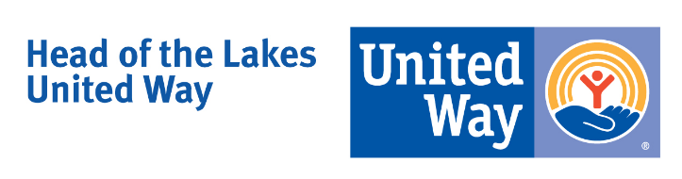

Position Title: Database Manager/ Campaign Associate
Status: Fulltime: 37.5 hrs/week
Employment Classification: Non-exempt
Reports to: Vice President of Impact & Development

Overview of Key Responsibilities

Database and Technical Support

- Provide support for the overall management and maintenance of the CRM donor and community building database software program (ANDAR) including daily entry, annual maintenance, updates, patches and rollovers
- Provide support with the development, implementation and maintenance of database protocols and procedures
- Run reports and conduct data mining operations necessary to meet the internal and external reporting needs of the campaign and community impact functions
- Work collaboratively with the Finance staff to ensure all donor information is collected and entered in accordance with finance policies and procedures
- Coordinate and submit campaign and community impact reports to United Way Worldwide
- In conjunction with community impact staff help maintain the ANDAR community building module for the community investment process and provide technical assistance to users accessing the grant management portal
- Provide assessments and recommendations for updating and ongoing improvement of the ANDAR database practices and system as needed or requested
- Assist with providing staff training and development, as needed, to support the efficient functioning of the ANDAR database including the development and monitoring of consistent and standardized procedures for all users
- Coordinate all donor information and updates including reviewing sources for changes or additions to campaign accounts and inputs weekly.

Annual Campaign

- Assist in the development and implementation of workplace campaigns including the Global Corporate Leader Accounts (online GCL’s), the State Combined Campaign application and supporting overall campaign efforts
- Coordinate campaign mailings including the residential, business, corporate gift, & stewardship
- Assist in campaign materials development, printing and inventory of all supplies
- Develop and distribute monthly Employee Campaign Coordinator enewsletters
- Collect and compile information relating to campaign activities (reports, forms, surveys)
- In conjunction with the campaign team, help organize annual campaign events
- Serve as campaign spokesperson as needed
- Attend regular campaign and resource development meetings

Administration and General Support

- In conjunction with the Marketing Director coordinate the ordering and inventory of campaign materials and supplies
- Prepare for campaign meetings: mailing notices, minutes, materials and room preparations
- Act as the initial contact for campaign calls and route to appropriate staff
- Under the direction of the VP of Impact and Development, provide the Marketing Director with current and ongoing information and data of campaign activity to promote the campaign
- Maintain confidentiality of records
- Perform other duties as assigned

Qualifications

- Bachelor’s Degree required; computer science, business or similar degree preferred
- ANDAR, Blackbaud, Razors Edge or similar donor and grant management database platforms experience- 2 plus years of comparable CRM management experience preferred
- Strong communication skills – written and verbal
- Strong computer and technological skills
- Data mining and data analysis experience
- Strong organizational skills & attention to detail
- Ability to handle multiple projects and meet deadlines

Benefits: Starting Minimum: $18.39/hr. Salary commensurate with experience and education. Health benefits provided.

To Apply:
Send resume, cover letter and three references by Friday, May 10th at 4:30pm to mhargrave@hlunitedway or mail to:

Michelle Hargrave, Vice President of Impact and Development
Head of the Lakes United Way
424 West Superior Street, Suite 402
Duluth, MN 55802
mhargrave@hlunitedway.org

